**Gait Monitoring and Analysis of Parkinson’s Disease Patients**

Ye Chen Rui1, Gupta Prannaya1 and Nallapuraju Ananya1

Mentor(s): Tay Arthur2

1 NUS High School of Mathematics and Science, 20 Clementi Ave 1, Singapore 129957

2 Electrical and Computer Engineering, National University of Singapore, 4 Engineering Drive 3, Singapore 117583

**PROJECT ABSTRACT**

Parkinson’s disease (PD) is a neurodegenerative disorder that affects the dopamine producing neurons in the substantia nigra, an area of the brain, leading to shaking, stiffness and difficulty walking. Parkinson’s patients frequently exhibit the debilitating condition, freezing of gait (FOG), which is when patients cannot move their feet forward despite the intention to walk. While the feet remain in place, the torso still has forward momentum, making falls very common. Several studies have reported methodologies to identify the PD patients at an early stage, such as PD scales and using Inertial Measurement Units (IMU). However, these methods are ineffective as scales are not personalised and the IMUs are generally big and bulky. In this study, acceleration data from the thigh of PD patients has been put through signal processing algorithms so as to postulate a generic Freeze Index, which is then run through multiple Support Vector Machine models to analyse and therefore predict FOG events. The analysis found that vertical and horizontal lateral acceleration was the most accurate at predicting FOG. Ultimately, a small and lightweight prototype was created based on acceleration data from accelerometers placed on the thigh.

**INTRODUCTION**

Parkinson’s Disease (PD) is a progressive neurodegenerative disorder that affects the substantia nigra, an area of the brain, resulting in the progressive loss of dopamine neurotransmitters and poorer connection between the central nervous system and muscles[1]. This leads to many gait abnormalities, mainly tremors, bradykinesia, rigidity, and a loss of postural reflexes. Secondary motor symptoms that are evoked include stride length reduction, shuffling gait, step festination and freezing[2,3].

Freezing of Gait (FOG) is one of the most debilitating effects of PD and is defined as a brief, episodic absence or marked reduction of forward progression of the feet despite the intention to walk[2]. It has serious social and clinical consequences for patients as it leads to falls[4] due to the torso still having forward momentum even though the feet remain in place, interferes with daily activities, and significantly impacts quality of life[5].

**AIMS AND OBJECTIVES**

As the prevalence of PD increases in our aging society, it is of increasing urgency that these elderly are kept safe. This study aims to compare multiple machine learning models that can analyse public PD datasets and extract their motion patterns. From which, FOG can be more efficiently predicted. This study also aims to create a wearable prototype and apply the findings to real life.

**HYPOTHESIS**

The Support Vector Machine performs the best under the Gaussian Kernel with all 3 parameters as training features.

**LITERATURE REVIEW**

***FOG Characterization***

Currently, FOG characterization is done using two main methods, gait tests and individual questionnaires. Gait tests include the timed up and go (TUG) test[6] and the Hoehn and Yahr (H&Y) scale[7].

In the second method, individual questionnaires are used. The Freezing of Gait Questionnaire (FOG-Q) is a notable one, comprising 6 questions and utilising a 5-point scale to rank symptom severity[8].

However, both methods are highly inefficient in measuring FOG as it is highly sensitive to environmental triggers, medication, and the patient’s mental state. Therefore, there has been research into using wearable inertial measurement units (IMUs) to display exactly the gait types of PD patients.

## ***Utilisation of IMUs in analysis***

This section reports previous studies which have explored the application of motion sensors on PD patients to accurately predict FOG. Ferster et al.[2] placed 9-axis IMUs (comprising 3D accelerometers, 3D gyroscopes and 3D magnetometers) on both ankles of the subjects to extract gait features such as stride length and stride duration. Moreover, as FOG exhibits unique frequency ranges, they introduce and discuss frequency features such as dominant frequency, dominant frequency amplitude and the inverse of the dominant frequency slope of the acceleration data to quantify changes in gait quality. Ferster was able to show specific changes in the stride duration, stride length, dominant frequency, and the inverse of the dominant frequency slope with up to four seconds prior to FOG on all subjects.

Baechlin et al.[9] proposed placing accelerometers at three different parts of the body: the shank, thigh, and lower back, where the wearable computer is attached to.

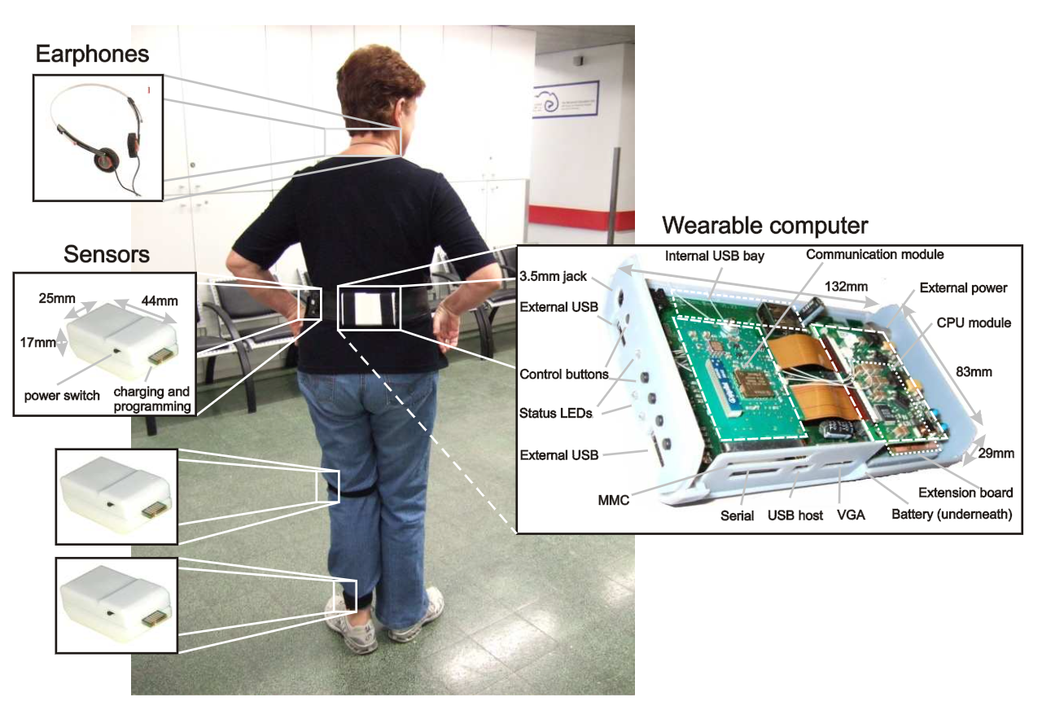

**Figure 1**: The Baechlin et al. 3-axial Accelerometer Wearable System

Alam et al.[10] analysed the vertical ground reaction force using force insoles in patients’ shoes to display gait cycles. Pinto et al.[11] again utilised accelerometers and gyroscopes to determine stride time, this time placing the accelerometer at the shank. In summary, a consolidated list of the main IMUs that were considered in this study is provided in Table 1.

|  |  |  |
| --- | --- | --- |
| **IMU** | **Purpose** | **Measured Parameter** |
| Accelerometer | Measuring acceleration | Stride Length, Stride Duration |
| Gyroscope | Measuring angular velocity | Step Festination, Gait Asymmetry |
| Flexible Goniometer | Measuring body joint angles | Flat Foot Strike |
| Force- sensitive Insole | Measuring the tension and compression forces that act on the sensor | Gait Cycle (not accurate for PD patients who suffer from flat footedness) |

**Table 1**: Table of possible IMUs

Many works have utilised motion capture systems to annotate FOG events, synchronising sensor data and computer analysis to make way for machine learning algorithms. Kuhner et al.[12] performed this experiment, setting up 12 cameras as well as utilising an inertial measurement suit to create a ‘live’ system that reduces the latency of data processing.

The above literature confirms the success of utilising accelerometers, gyroscopes, and force insoles to effectively differentiate FOG from normal gait and has greatly helped in designing the proposed approach for this study.

***Gait parameters to be analysed***

|  |  |
| --- | --- |
| **Gait abnormalities** | **Definition** |
| Step Festination | Shortening of steps |
| Decrease in Stride Duration | Decrease in the time difference between two consecutive detected acceleration peaks of the same leg |
| Postural Instability | Loss of balance |
| Increase in step-to-step time variability | Difference in time taken between each stride |
| Stride Length Reduction | Reduction in distance between each stride/step |
| Decreased Cadence | Decrease in number of steps taken per unit time |
| Gait Asymmetry | Difference in gait between the two legs of patient |

**Table 2**: Summary of Gait parameters found in this research

Accelerometers have been chosen to be the focus of the data analysis as they are very versatile. Previous research has shown that accelerometers can be used to determine key gait parameters like stride time, gait cycle and gait velocity. Hence, they would be a good starting point.

## 

**METHODOLOGY**

## ***DAPHNet Dataset***

In the main investigation, the Daphnet Freezing in users with Parkinson's disease (hereafter known as the DAPHNet Dataset) is employed, and is the result of a study done by Baechlin et al.[9], carried out by the Laboratory for Gait and Neurodynamics, Department of Neurology, Tel Aviv Sourasky Medical Center (TASMC). In this experiment, 17 samples were derived from 10 PD patients who were made to do various walking tasks, including walking back and forth in a straight line, doing several 180 degrees turns, random walking including a series of initiated stops and 360 degree turns and walking simulating daily activities[1].

Data was recorded using three 3D acceleration sensors attached to the shank, thigh, and the lower back of each subject. The sensors recorded at 64Hz and transmitted the acceleration data via a Bluetooth link to a wearable computing system that was located at the lower back of the subjects.

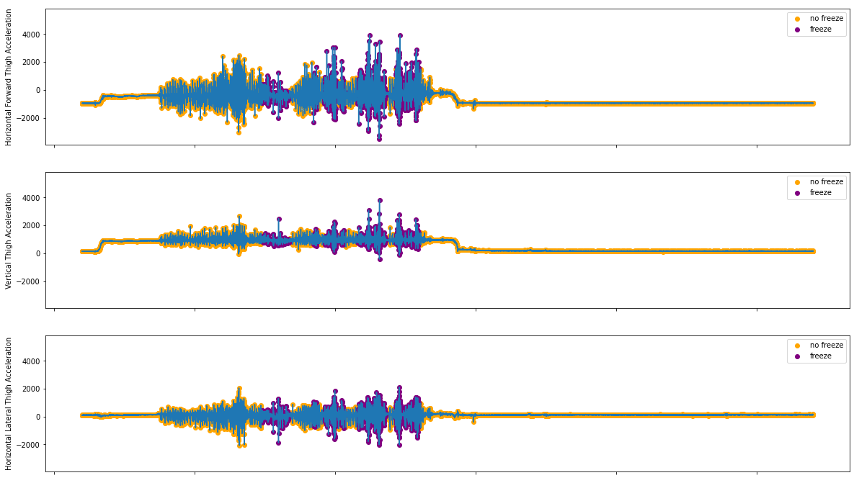

**Figure 2**: Acceleration Data from S03R02.txt. The blue line depicts the acceleration data provided.

## ***Signal Processing***

This study uses signal processing algorithms to compute a postulated freeze index (FI). Moore et al.[13] defined the FI as the power ratio of freeze band (0.5–3.0 Hz) to locomotor band (3–8 Hz) derived from the frequency spectrum. The FI is postulated as a unitless magnitude of resistance experienced in the direction of acceleration from which it is tabulated. This approach was chosen instead of generic gait parameters because it was a lot more accurate and took into account many other crucial factors in our investigation, like the rhythmic movement of the legs in normal and abnormal walking, gait velocity abnormalities and others.

Moore et al. later identified FOG episodes at the time periods when FI exceeds a certain threshold. The code uses an updated form of Moore’s algorithm, wherein it calculates the FI from data from a specific axis (horizontal forward, horizontal lateral and vertical) from the sensors on the thigh by performing windowing of data with a length of 256 data points and steps up 32 data points. After performing a mean normalisation, the code finds the Fast Fourier Transform of the normalised window and uses that to compute the FI and supposed Power Spectral Density (PSD). After this, it accounts for a standing case where the , and in cases where it is below this threshold, the FI becomes zero. This postulated FI was then considered.

In this experiment, a final function freeze(N) is defined, where

*freeze(N) = FI postulated from the N-axis acceleration data*

For this investigation, the axes were defined as follows:

|  |  |
| --- | --- |
| **Axis** | **Axis with respect to the user** |
| X | Horizontal Forward |
| Y | Vertical |
| Z | Horizontal Vertical |

## 

## ***SVM Analysis***

Unlike Baechlin et al.[9], where the FI with a threshold of *1.5* is used such that a FI greater than the threshold is considered FOG, SVM models have been tested against the derived FI values. This was in-line with a comprehensive review of four different types of machine learning algorithms (Support Vector Machine (SVM); k-Nearest Neighbour (kNN); Decision Tree (DT) and Naïve Bayes (NB)) in classifying patients with FOG or no FOG done by Aich et al[14]. They found that the SVM classifier with radial basis function provides the highest accuracy of 91.42% as well as the highest sensitivity and specificity of 90.89% and 91.21% respectively.

Due to the large amount of data amassed from the signal processing algorithms, the Google Colaboratory Tool[15] is used. It allows Graphics Processing Units (GPUs) of more powerful computers at Google to be utilised. This allows the SVM to run much faster such that results can be obtained faster for the investigation. The ThunderSVM utility[16] developed by the Xtra Computing Group at the NUS School of Computing (SoC) is also used to fully utilise the GPUs.

For the investigation, Linear and Gaussian Kernels have been employed and these SVMs are tested with either 2-axial freeze indices (i.e. taking freeze indices from 2 of the 3 axes defined) or 3-axial freeze indices (which took into account freeze(X), freeze(Y) and freeze(Z)).

***Arduino Program***

The program has been developed using Arduino's programming language based on the C++ programming language. To get the best SVM model, a program called sklearn-porter[17] developed by Darius Morawies, which converts the trained SVM model to C code, saved as a model.h file, has been utilised. This model is accessed by the Arduino Program, which also computes the freeze values.

## Arduino Pinout Diagram with Built-In LED Information

**Figure 3**: The Arduino Nano 33 BLE Pinout Diagram. The built-in LED lights up upon detection of a freeze event.

This study utilises an Arduino Nano 33 BLE board that is attached to an elastic strap. It contains a 9-axial IMU, comprising a 3D accelerometer, 3D gyroscope and 3D magnetometer. In the program, upon a certain freeze event predicted by the SVM, the built-in light-emitting diode (LED) will turn on.

**RESULTS AND DISCUSSION**

Upon performing the signal processing algorithms, the postulated function arrays for freeze(X), freeze(Y) and freeze(Z) are obtained. Below are the freeze indices based on the acceleration data shown in Figure 2.

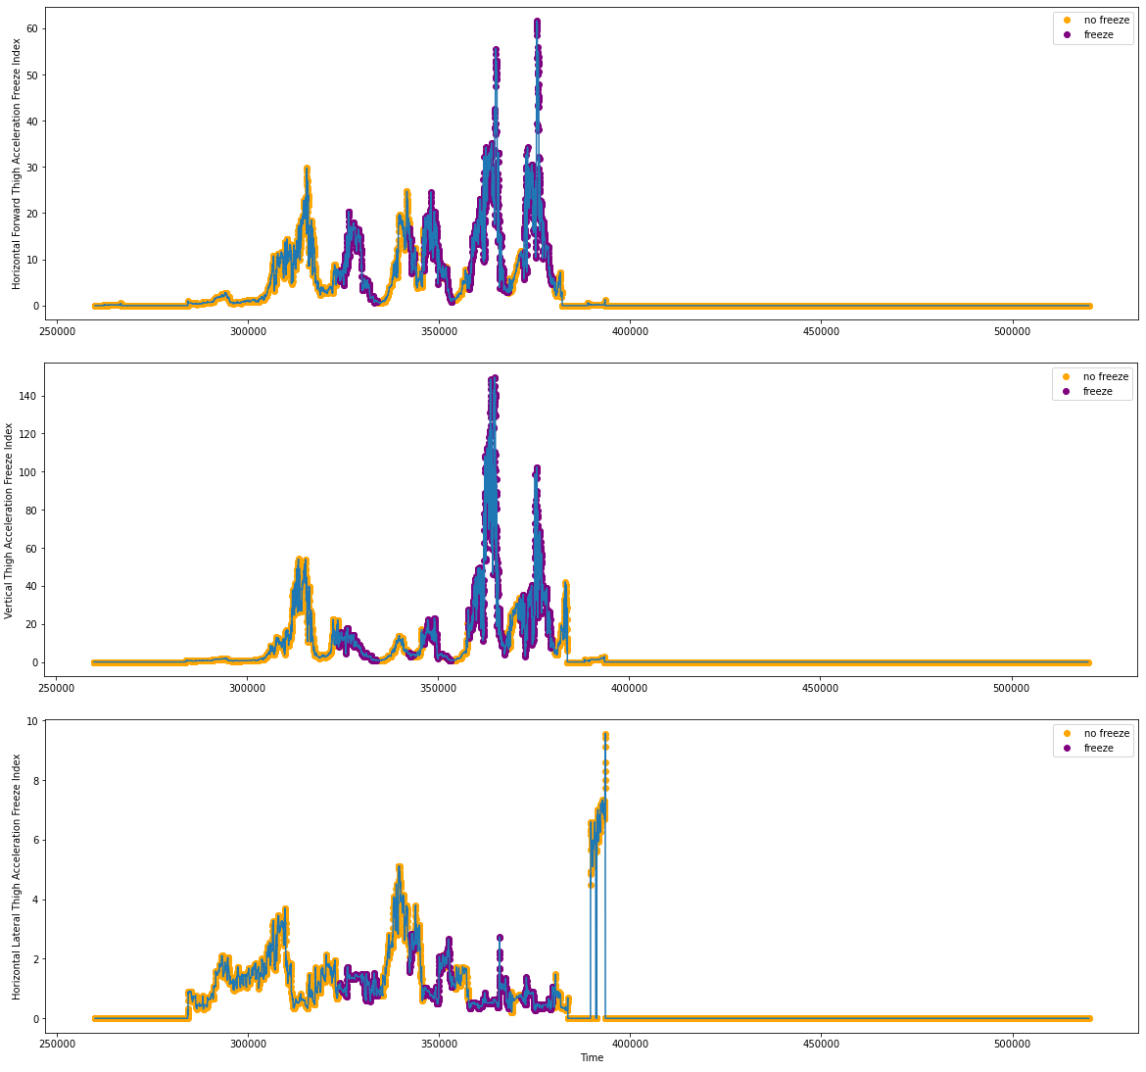

**Figure 4**: FI Tabulations from S03R02.txt

All 17 samples are merged and taken as the main argument X in the supervised machine learning structure. From here, a provided freeze value for each point given by the dataset itself has been taken to function as the y argument. Below, all freeze indices are plotted against one another.

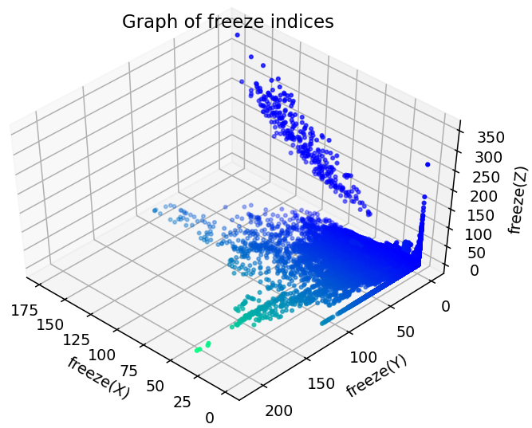

**Figure 5**: Plot of Freeze Indices

Performing an SVM analysis using ThunderSVM, the following results have been obtained:

|  |  |  |  |  |  |  |
| --- | --- | --- | --- | --- | --- | --- |
| **Kernel** | **Parameters** | **Specificity** | **Sensitivity/ Recall** | **Precision** | **Accuracy** | **F1 Score** |
| **Linear Kernel** | freeze(X) and freeze(Y) | 1.000 | 0.000 | 0.000 | 0.903 | 0.000 |
| freeze(X) and freeze(Z) | 0.975 | 0.243 | 0.509 | 0.904 | 0.329 |
| **freeze(Y) and freeze(Z)** | **1.000** | **0.006** | **0.889** | **0.904** | **0.011** |
| All 3 parameters | 1.000 | 0.002 | 0.867 | 0.904 | 0.005 |
| **Radial Basis Kernel** | freeze(X) and freeze(Y) | 0.990 | 0.174 | 0.650 | 0.911 | 0.275 |
| freeze(X) and freeze(Z) | 0.990 | 0.183 | 0.664 | 0.912 | 0.286 |
| freeze(Y) and freeze(Z) | 0.991 | 0.163 | 0.665 | 0.911 | 0.262 |
| All 3 parameters | 0.989 | 0.260 | 0.723 | 0.918 | 0.382 |

**Table 3**: Table of Algorithm Evaluation Functions with regards to kernels and parameters

Based on the results, it is believed that the Linear Kernel with parameters freeze(Y) and freeze(Z) is the best since it is highly accurate, specific and precise. After conducting an analysis, it is found that the weighted average value for precision and sensitivity/ recall as 0.90 and weighted average F1 score as 0.86. The decision boundary function is shown below.

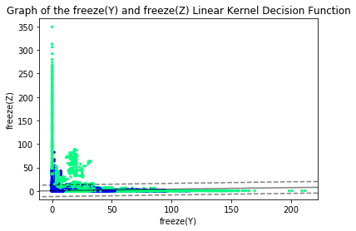

**Figure 6**: Decision Boundary of freeze(Y) and freeze(Z) SVM under Linear Kernel

***Prototype***

In the end, a prototype (shown in Figure 7) has been developed to verify the effectiveness of parameters based on public dataset analysis. It consists of an Arduino Nano 33 BLE board with a built-in 9-axial IMU consisting of a 3D accelerometer and 3D gyroscope attached to an elastic band. It is small, light, very comfortable and is meant to be wrapped around the thigh.

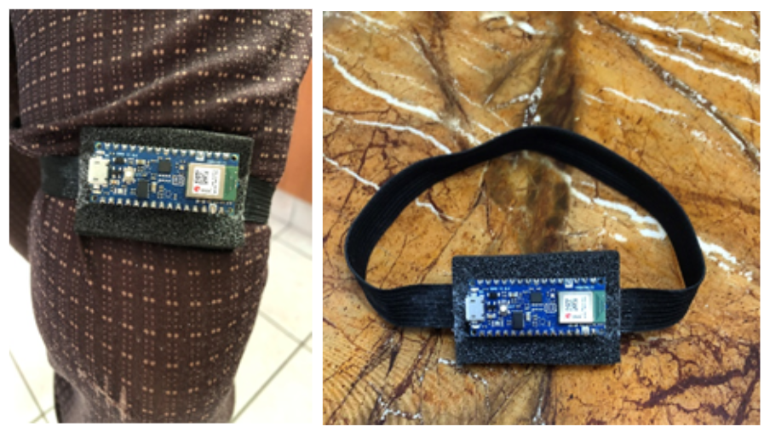

**Figure 7**: The Prototype

***Final Application***

The final product of this research project was an independent Android Application developed in Kotlin, which we titled “Gait Analyzer”. This application uses phone sensors to monitor these gait patterns and performs simplistic signal processing. There are two different systems, and users can sign in either as a Patient or a Caregiver. The Patient has the option to activate a “Walk Mode” such that when he walks, events such as Freeze Events or Fall Events will be detected, and appropriate action will be taken to counteract the effects of these events.

The application was created with the User Interface taken into account. Since the majority demographic of the patients are elderly patients, it is ideal to make the application process as simplistic as possible. Buttons and TextViews were enlarged and authentication processes were not complicated. The application was also connected to Google’s Firebase’s Cloud Firestore and Cloud Storage services, where user-specific authentication data and freeze data were stored respectively. Database design was also taken into consideration and authentication data was stored in a NoSQL database while freeze data was stored in the form of a CSV in Firebase Storage.

Users could also monitor the number of freeze events in separated tabs, whether in the form of a calendar widget or a master/detail flow. Bar Graphs powered by the MPAndroidChart utility were utilised to show freeze data by hour. Information regarding the app was given in separate pages too.

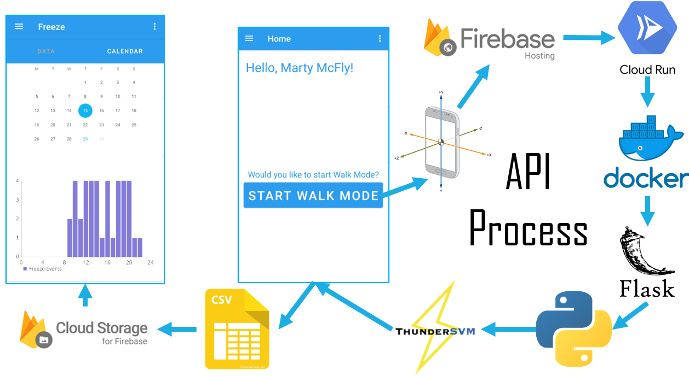

**Figure 8**: The above details the process the Android Application takes.

**CONCLUSIONS**

After analyzing multiple machine learning models that have used acceleration data from accelerometers placed on the thigh, the most suitable parameters for classification are freeze(Y) and freeze(Z). The best model is the Linear Kernel model in terms of sensitivity. Furthermore, a prototype has been implemented using an Arduino Nano 33 BLE board.

As Parkinson's Disease is becoming increasingly prevalent amongst the elderly population in Singapore, more elderlies are at the risk of falling and injuring themselves in cramped HDB spaces. Using the developed algorithm, prototype and mobile application, such falls can be predicted so that they can be mediated in time.

**FUTURE WORK**

There are a few improvements that could have been done to the project. Due to time limitations, only accelerometers were studied in this project, which could have limited the sensitivity of the device. Multiple sensors can be combined to achieve maximum accuracy including gyroscopes to find out rotational motion parameters as well. Additionally, only postulated Freeze Index values have been analysed based on the public datasets. Parameters such as Stride Length and Stride Duration have not been studied. In the future, such parameters can be taken into account when computing the general gait freeze moment. The sensitivity of the algorithm can also be improved. Since the prototype has already been built, the next phase is to test it in a laboratory with Parkinson’s Disease patients in order to determine its accuracy.

Furthermore, by connecting this system to earbuds and implementing biofeedback via audio, the system can also mediate FOG. Another method involves connecting the system to an App such that notifications can be sent to the caregiver’s phone to alert them to a fall. This can be developed via Android App Development with Java/ Kotlin, iOS App Development with Swift/ Objective-C or via cross-platform frameworks like Kivy, React Native/ Ionic, Xamarin or Flutter for Python, JavaScript, .NET/ C#, and Dart Programming respectively.

**ACKNOWLEDGEMENTS**

We would like to thank Professor Arthur Tay, Mr Lim Yeow Heng and Mr Lim Teck Choow for their support and encouragement in this study.

**REFERENCES**

[1] Braak, H., Ghebremedhin, E., Rüb, U., Bratzke, H., & Del Tredici, K. (2004). Stages in the development of Parkinson’s disease-related pathology. Cell and Tissue Research, 318(1), 121–134. <https://doi.org/10.1007/s00441-004-0956-9>

[2] Ferster, M. L., Mazilu, S., & Tröster, G. (2015). Gait Parameters Change Prior to Freezing in Parkinson's Disease: A Data-Driven Study with Wearable Inertial Units. Proceedings of the 10th EAI International Conference on Body Area Networks. <https://doi.org/10.4108/eai.28-9-2015.2261411>

[2] Nutt, J. G., Bloem, B. R., Giladi, N., Hallett, M., Horak, F. B., & Nieuwboer, A. (2011). Freezing of gait: moving forward on a mysterious clinical phenomenon. The Lancet Neurology, 10(8), 734–744. <https://doi.org/10.1016/s1474-4422(11)70143-0>

[3] Jankovic, J. (2008). Parkinson’s disease: clinical features and diagnosis. Journal of Neurology, Neurosurgery & Psychiatry, 79(4), 368–376. <https://doi.org/10.1136/jnnp.2007.131045>

[4] Bloem, B. R., Hausdorff, J. M., Visser, J. E., & Giladi, N. (2004). Falls and freezing of gait in Parkinson’s disease: A review of two interconnected, episodic phenomena. Movement Disorders, 19(8), 871–884. <https://doi.org/10.1002/mds.20115>

[5] Moore, O., Peretz, C., & Giladi, N. (2007). Freezing of gait affects quality of life of peoples with Parkinson’s disease beyond its relationships with mobility and gait. Movement Disorders, 22(15), 2192–2195. <https://doi.org/10.1002/mds.21659>

[6] Podsiadlo, D., & Richardson, S. (1991). The Timed “Up & Go”: A Test of Basic Functional Mobility for Frail Elderly Persons. Journal of the American Geriatrics Society, 39(2), 142–148. <https://doi.org/10.1111/j.1532-5415.1991.tb01616.x>

[7] Hoehn, M. M., & Yahr, M. D. (1967). Parkinsonism: onset, progression, and mortality. Neurology, 17(5), 427. <https://doi.org/10.1212/wnl.17.5.427>

[8] Rozenfeld, S., Miskovic, A., Nitsch, K. P., & Ehrlich-Jones, L. (2017). Measurement Characteristics and Clinical Utility of the Freezing of Gait Questionnaire in Individuals With Parkinson Disease. Archives of Physical Medicine and Rehabilitation, 98(10), 2106–2107. <https://doi.org/10.1016/j.apmr.2017.04.027>

[9] Bachlin, M., Plotnik, M., Roggen, D., Maidan, I., Hausdorff, J. M., Giladi, N., & Troster, G. (2010). Wearable Assistant for Parkinson’s Disease Patients With the Freezing of Gait Symptom. IEEE Transactions on Information Technology in Biomedicine, 14(2), 436–446. <https://doi.org/10.1109/titb.2009.2036165>

[10] Alam, M. N., Garg, A., Munia, T. T. K., Fazel-Rezai, R., & Tavakolian, K. (2017). Vertical ground reaction force marker for Parkinson’s disease. PLOS ONE, 12(5), e0175951. <https://doi.org/10.1371/journal.pone.0175951>

[11] Pinto, C., Schuch, C. P., Balbinot, G., Salazar, A. P., Hennig, E. M., Kleiner, A. F. R., & Pagnussat, A. S. (2019). Movement smoothness during a functional mobility task in subjects with Parkinson’s disease and freezing of gait – an analysis using inertial measurement units. Journal of NeuroEngineering and Rehabilitation, 16(1). <https://doi.org/10.1186/s12984-019-0579-8>

[12] Kuhner, A., Schubert, T., Maurer, C., & Burgard, W. (2017). An online system for tracking the performance of Parkinson’s patients. 2017 IEEE/RSJ International Conference on Intelligent Robots and Systems (IROS). <https://doi.org/10.1109/iros.2017.8205977>

[13] Moore, S. T., MacDougall, H. G., & Ondo, W. G. (2008). Ambulatory monitoring of freezing of gait in Parkinson’s disease. Journal of Neuroscience Methods, 167(2), 340–348. <https://doi.org/10.1016/j.jneumeth.2007.08.023>

[14] Aich, S., Pradhan, P., Park, J., Sethi, N., Vathsa, V., & Kim, H.-C. (2018). A Validation Study of Freezing of Gait (FoG) Detection and Machine-Learning-Based FoG Prediction Using Estimated Gait Characteristics with a Wearable Accelerometer. Sensors, 18(10), 3287. <https://doi.org/10.3390/s18103287>

[15] Bisong E. (2019) Google Colaboratory. In: Building Machine Learning and Deep Learning Models on Google Cloud Platform. Apress, Berkeley, CA. <https://doi.org/10.1007/978-1-4842-4470-8_7>

[16] Wen, Z., Shi, J., Li, Q., He, B., & Chen, J. (2018). ThunderSVM: A Fast SVM Library on GPUs and CPUs, Journal of Machine Learning Research, 19, 797–801.

[17] Morawiec, D. (n.d.). sklearn-porter - Transpile trained scikit-learn estimators to C, Java, JavaScript and others. <https://github.com/nok/sklearn-porter>

1. Daily activities refer to entering and leaving rooms, getting something to drink and returning to the starting room with the cup of water.